Lab 1-1: Installation and usage of Dev-C++ and online compilers

Objective:
The objective of this lab is to teach students how to install and use the Dev-C++ and online compilers.

Learning Outcomes:
After this lab, the students will be able to run the C++ code in Dev-C++ and the online compilers.

Problem Statement

You are required to install any version of Dev-C++ in your system according to your system and operating system requirements.

Dev C++ 4.9.9.2 Installation Guide
Installation Steps:

Step 1:
Double-click on the file devcpp_setup.exe and Click on the “Run” button.

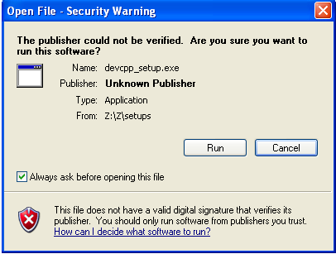

Step 2:
Click on the “OK” button.

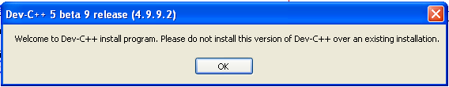

Step 3:
Click on the “OK” button.

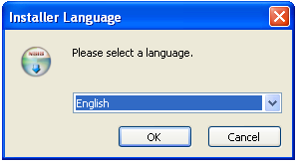

Step 4:
Click on the “I Agree ” button.
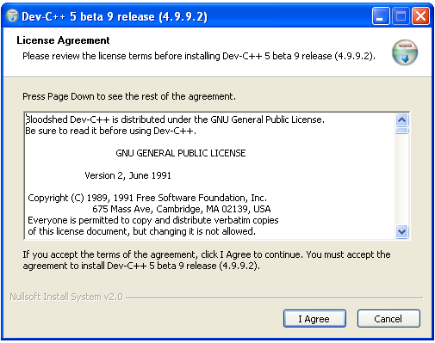

Step 5:
Click on the “Next” button.

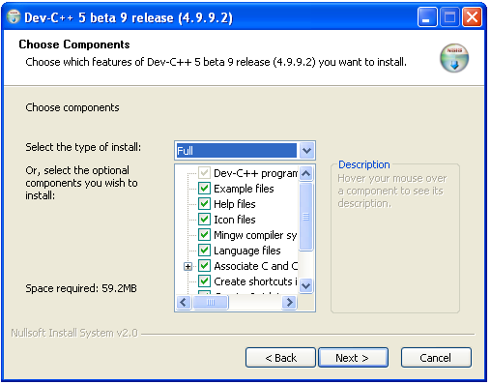

Step 6:
Click on the “Install” button.

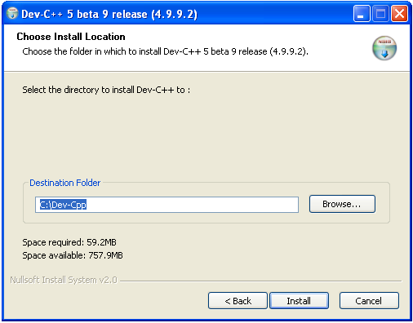
Step 7:
Wait until the green bar completed
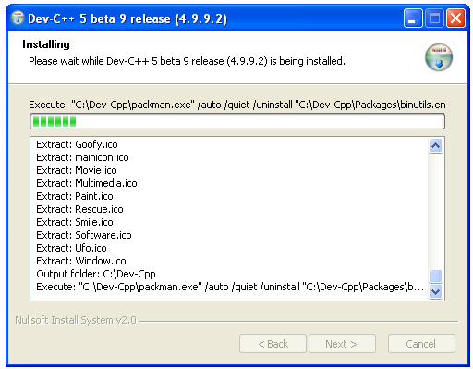

Step 8:
Click on the “Finish” button.
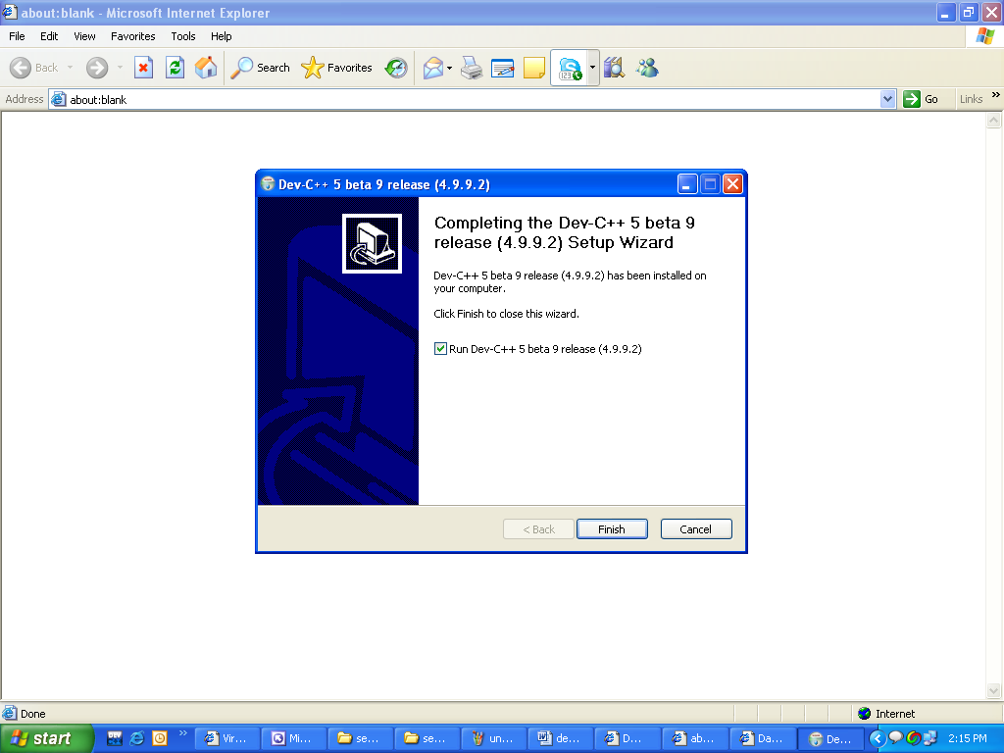

Your Dev C++ 4.9.9.2 has been installed successfully. Now start writing compiling and running programs and enjoy programming.

Dev C++ 5.9 Installation Guide

Installation Steps:

Step 1:
Double-click on the file devcpp_setup.exe and Click on the “Run” button.

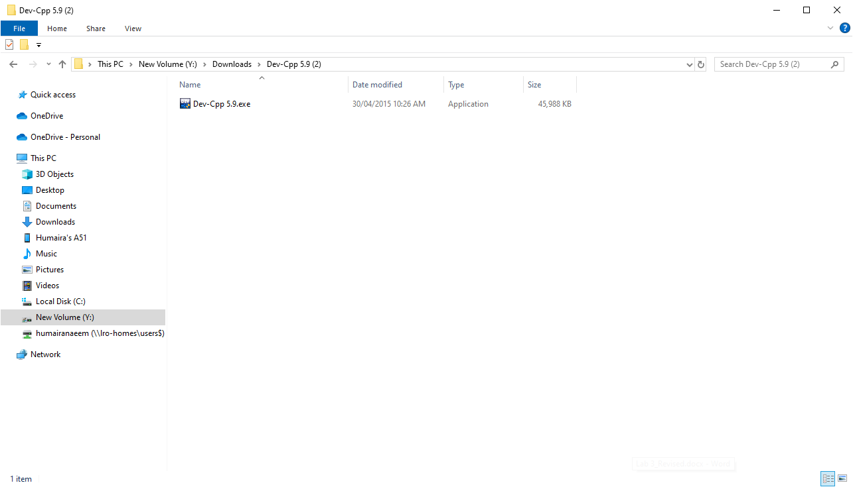

Step 2:
Click on the “OK” button.
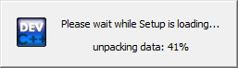

Step 3:
Click on the “OK” button.

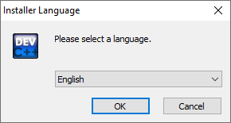

Step 4:
Click on the “I Agree ” button.

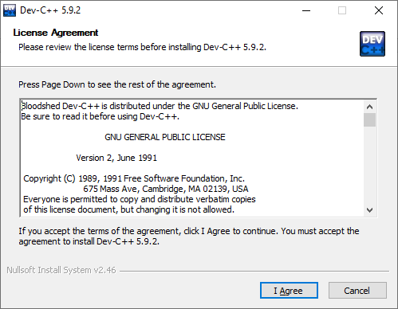

Step 5:
Click on “Next” button.

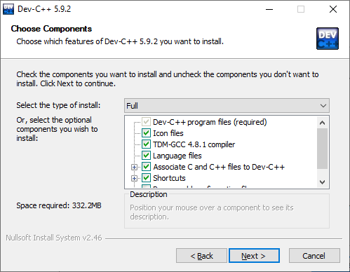

Step 6:
Click on “Install” button.
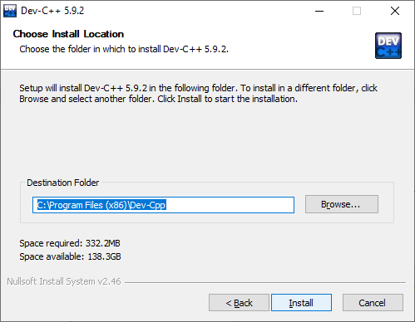
Step 7:
Wait until the green bar completed
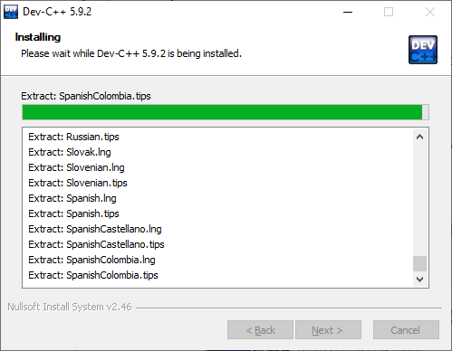
Step 8:
Click on “Finish” button.
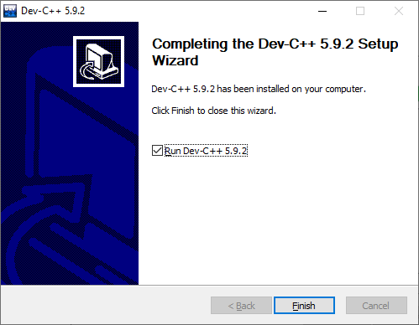
Your Dev C++ 4.9.9.2 has been installed successfully. Now start writing compiling and running programs and enjoy programming.

Guidelines on how to use Dev-C++

Following are the steps to write, save, compile, and run a program, using Dev-C++:

How to open Dev-C++:

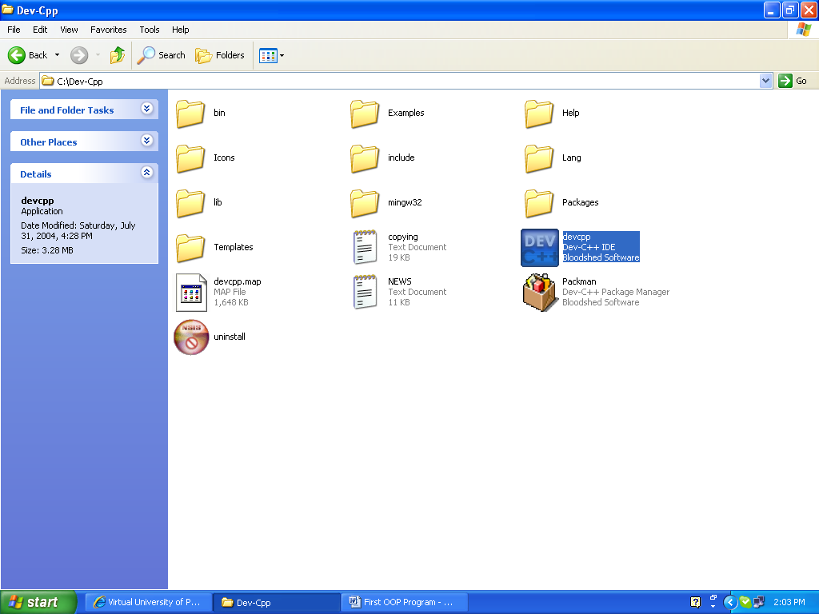

Main interface of Dev-C++:

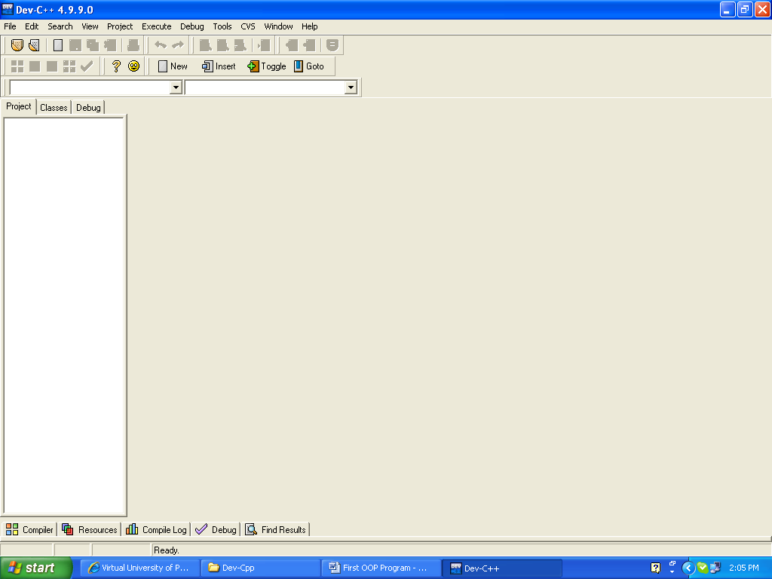

Write a new Program:

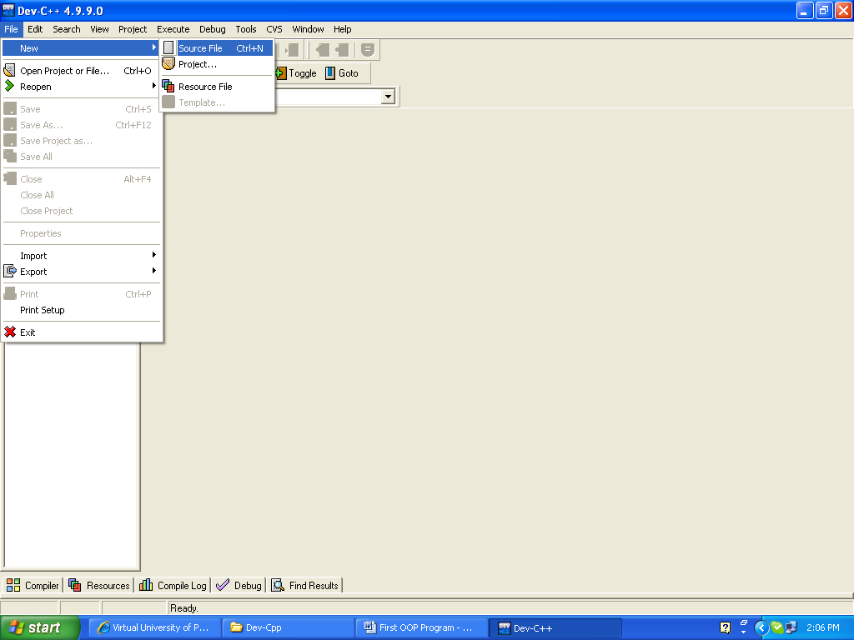

Where to write the code:

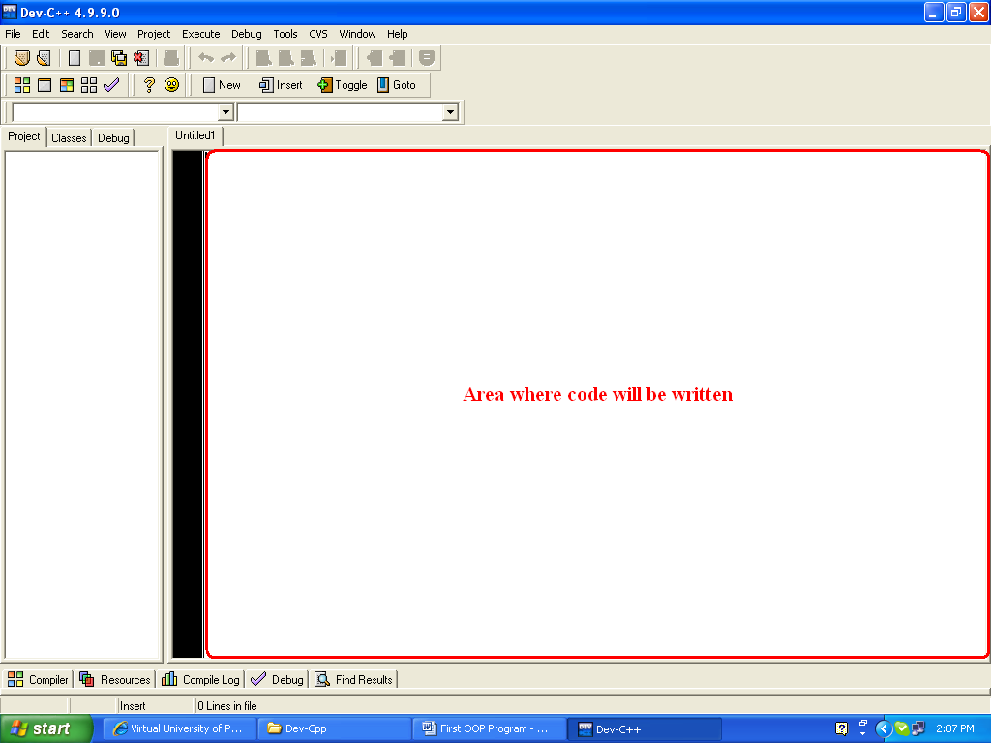

After writing your code:

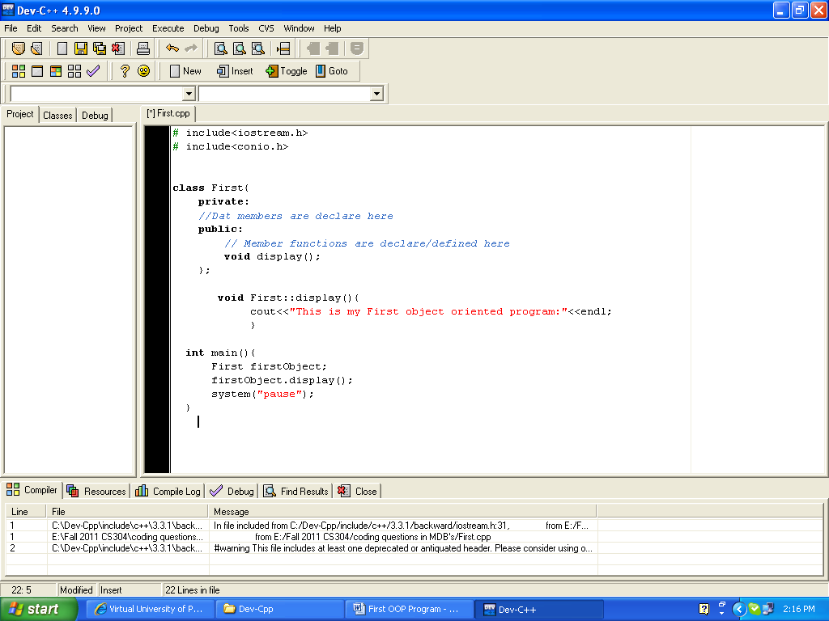

Save the Program:

1st Step:

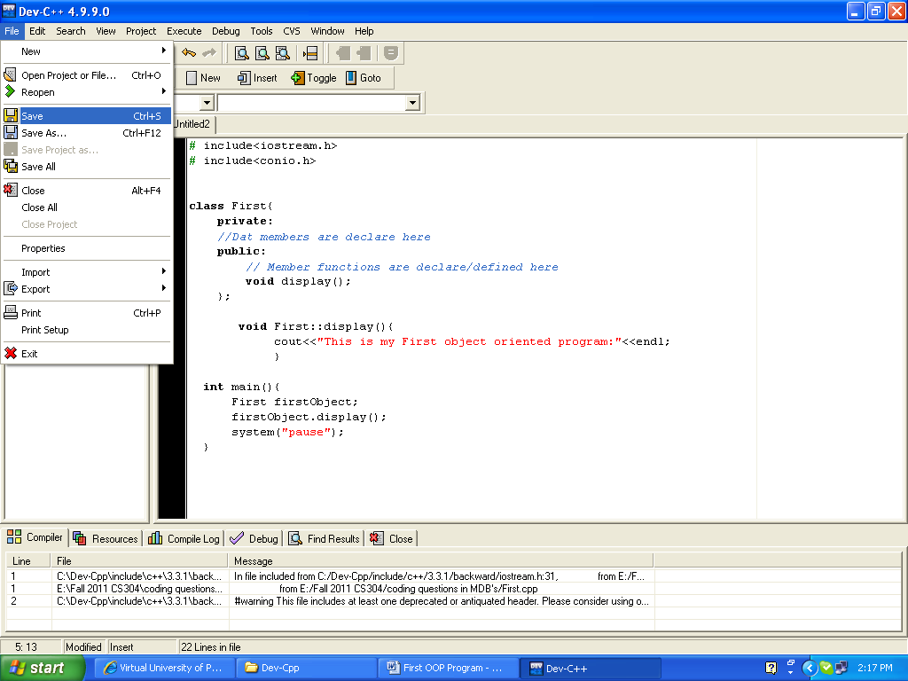

2nd Step:

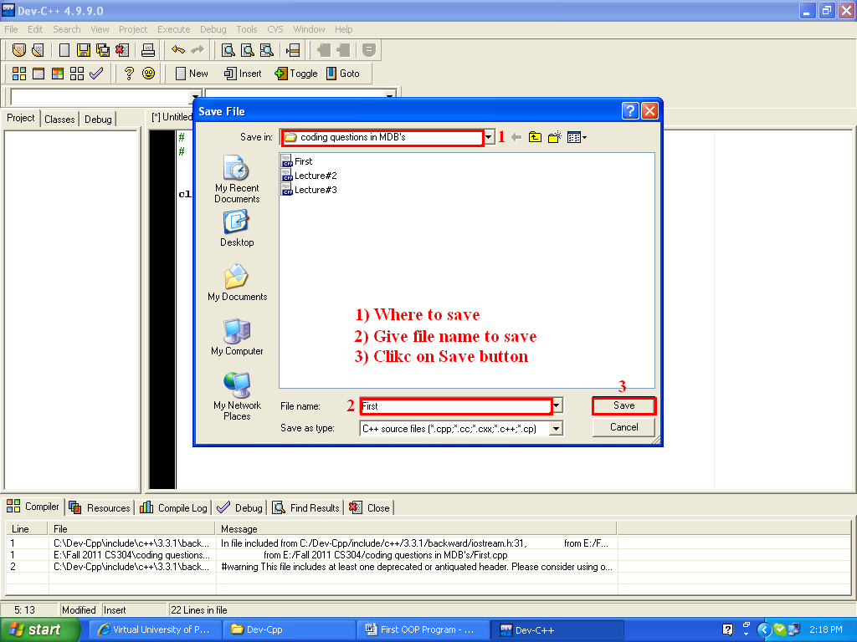

How to compile the program:

1st Step:

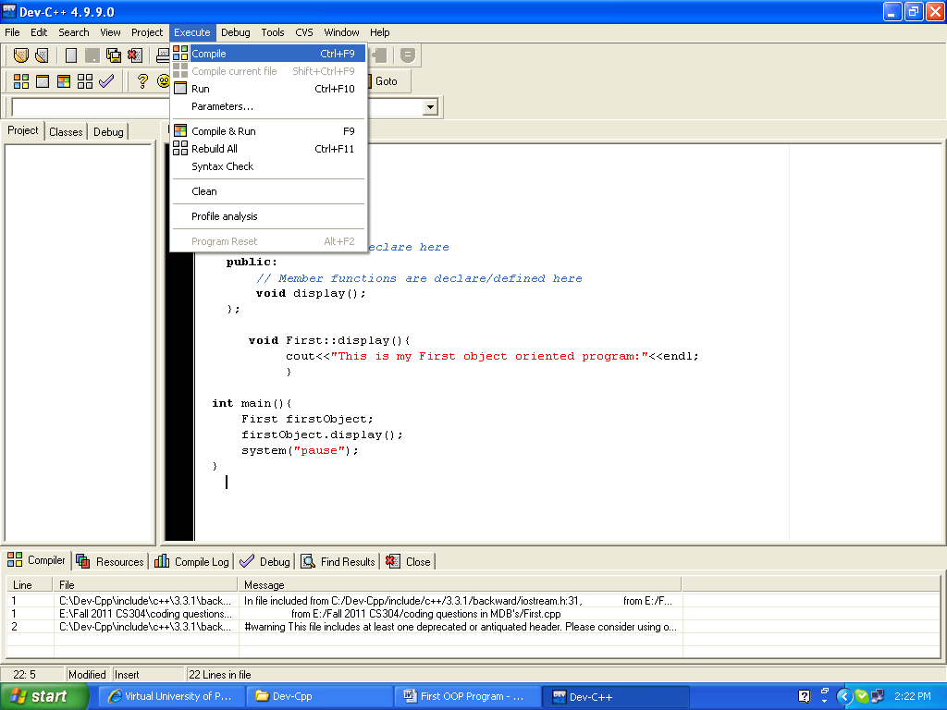

2nd and 3rd step will be performed automatically

2nd Step:

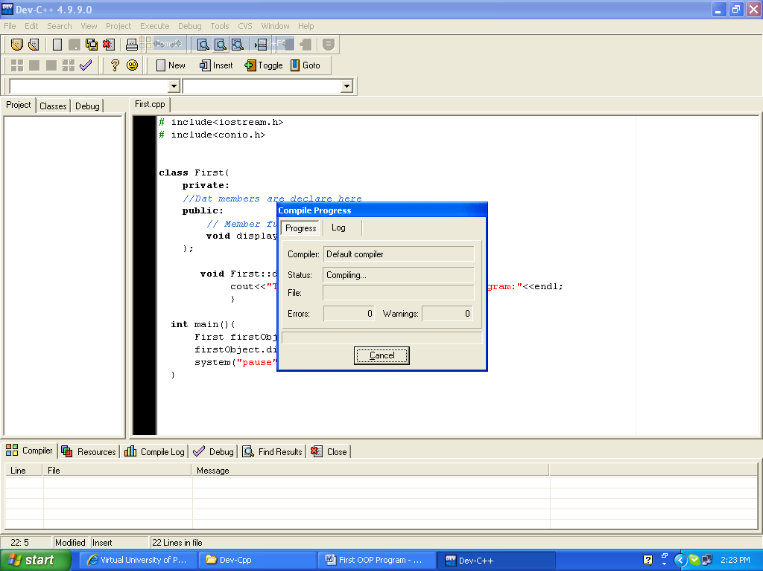

3rd Step:

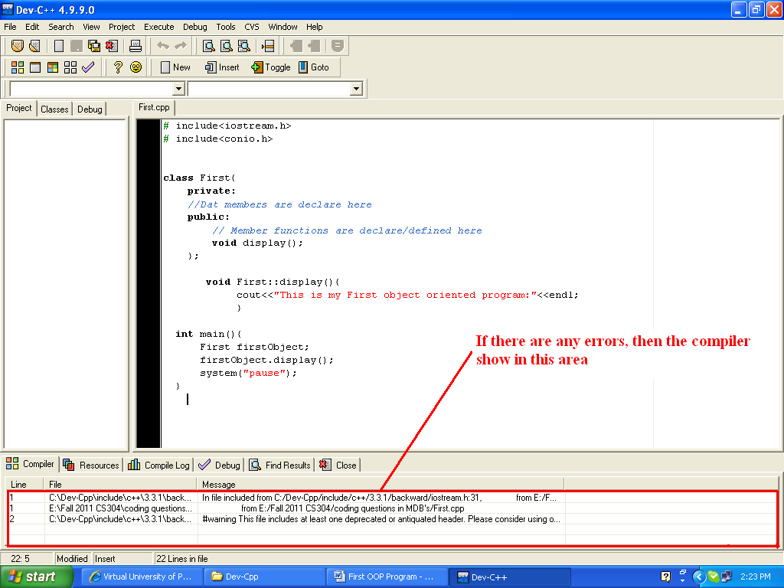

How to run the program:

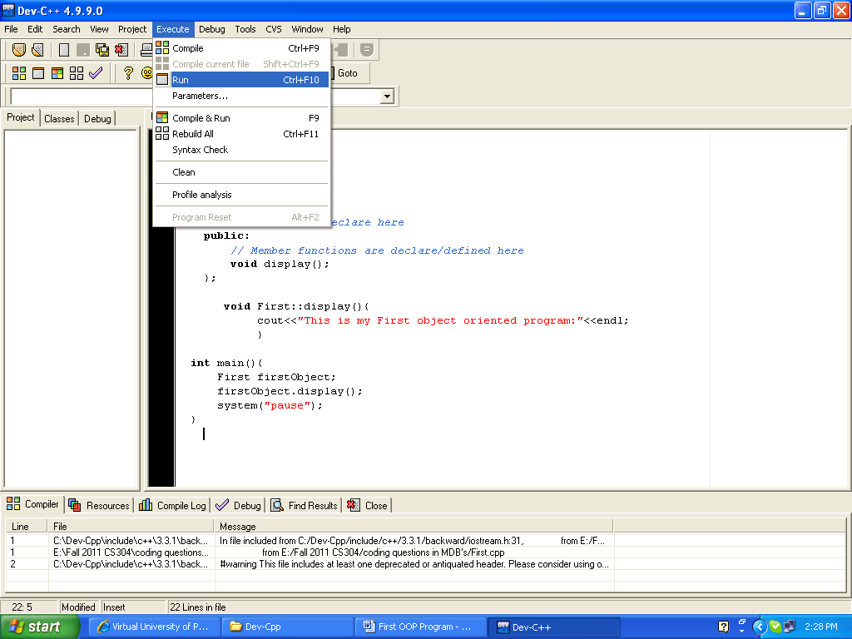

Output will be displayed as:

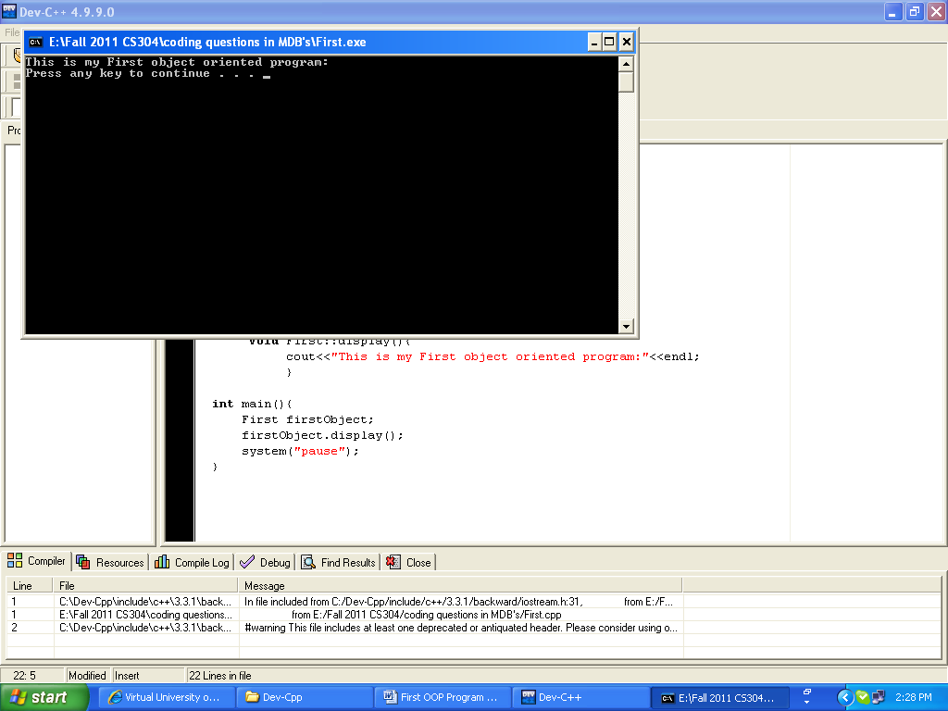

Guidelines on how to use online C++ compiler

Following are the steps to write, compile, and run a program using an online compiler:

Open a browser and type the following address in the address bar.
https://www.programiz.com/cpp-programming/online-compiler/

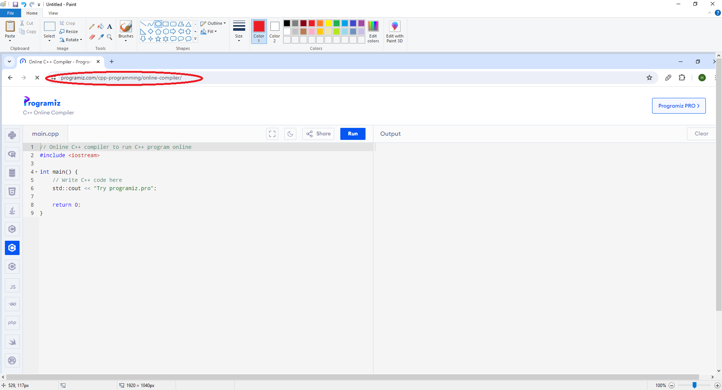

Now, write the C++ code in the highlighted area.
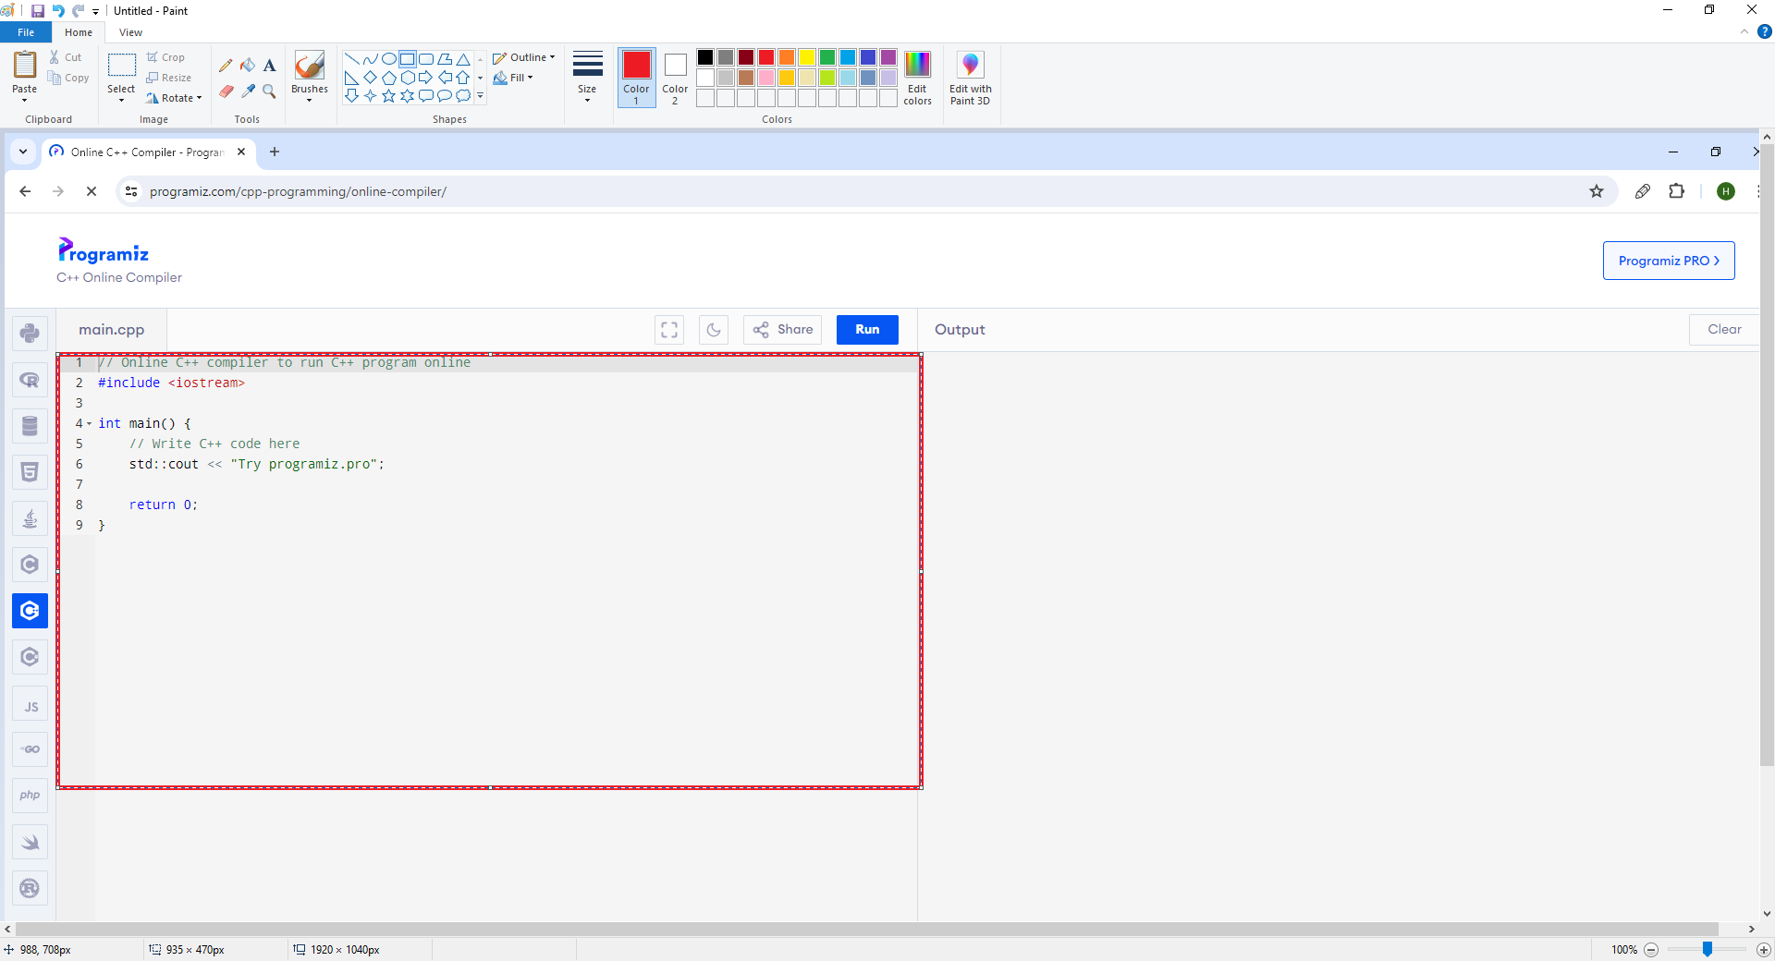

Write your C++ code in the highlighted area.

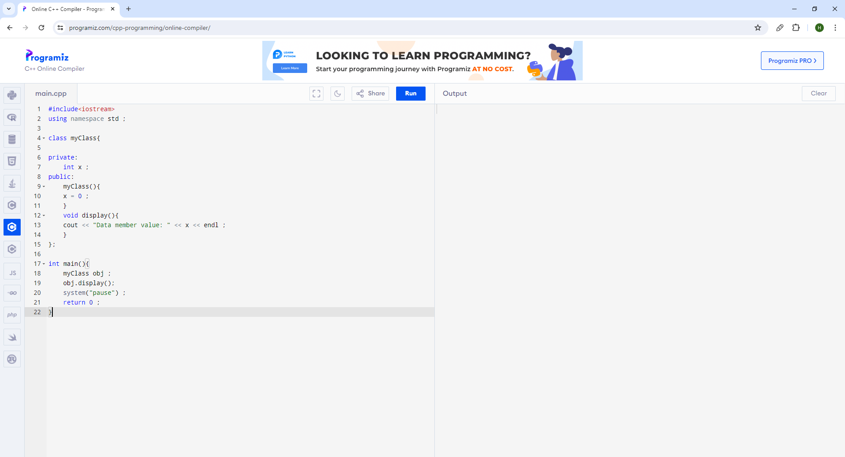

After writing the code, click on the ‘Run’ button.

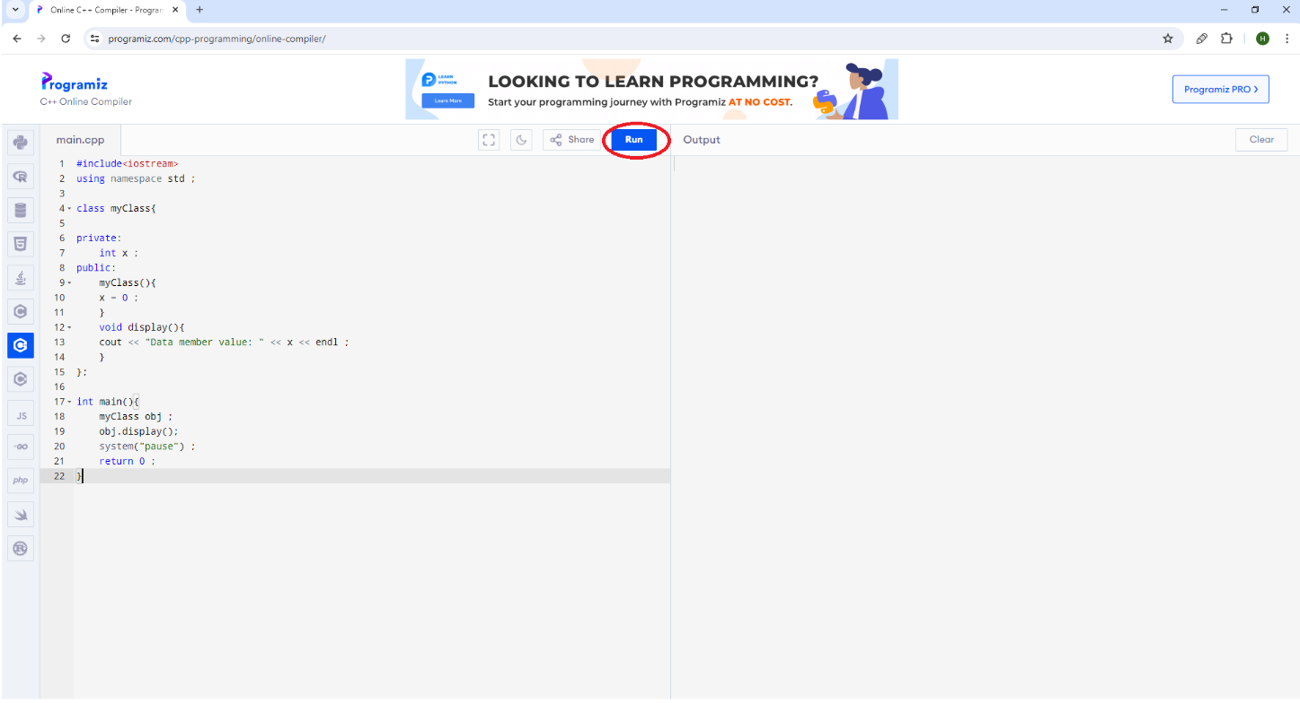

The output of the code will be shown in the highlighted area.

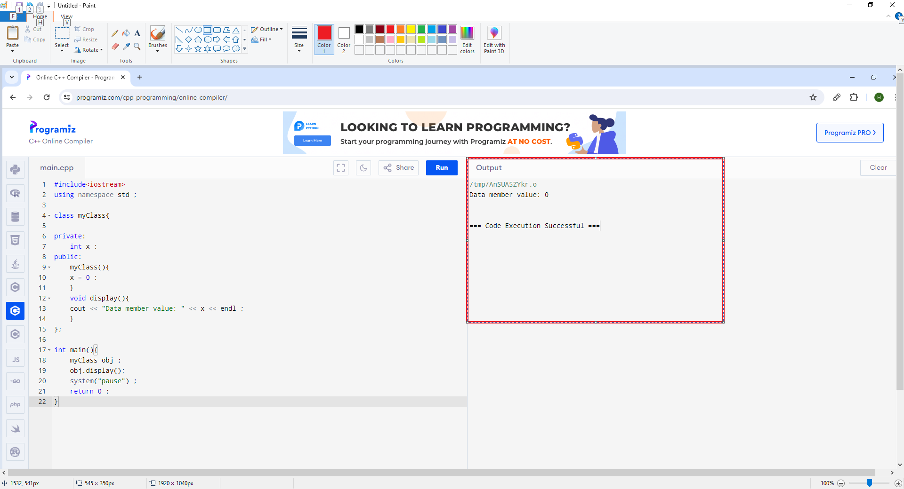
If the program contains syntax errors, then errors will be shown along with the line number in the highlighted area.

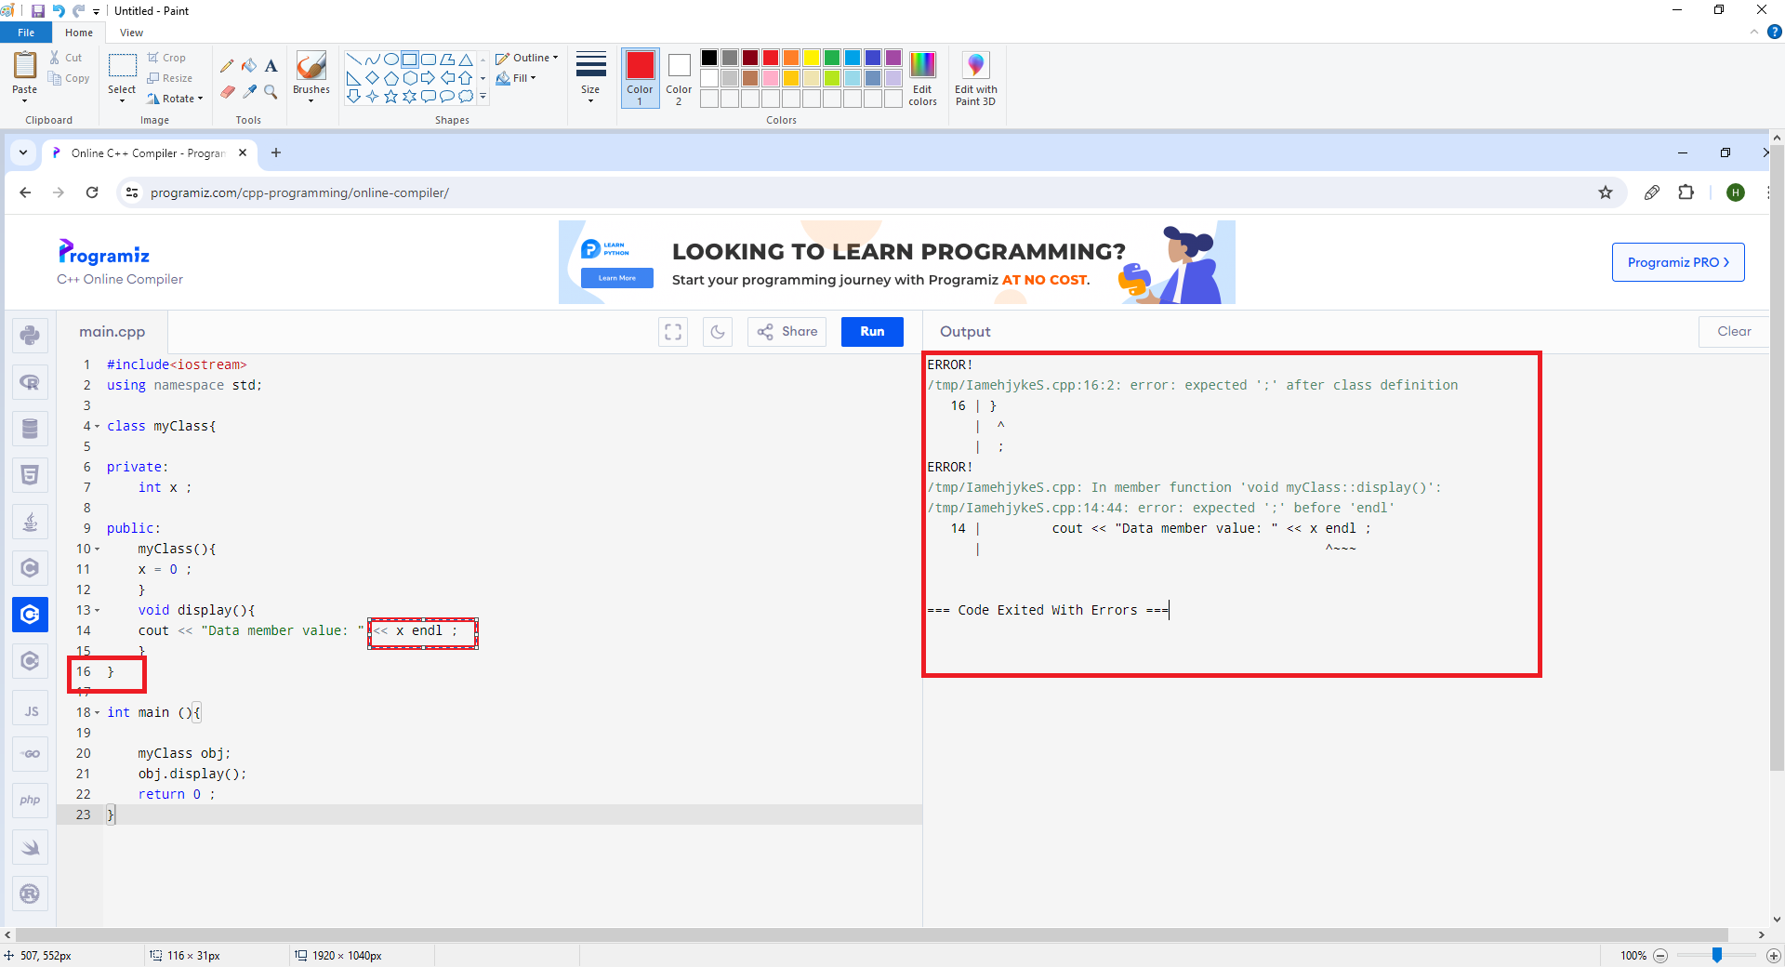

After removing the syntax errors, click on the ‘Run’ button again to see the output.

